EXPERIMENT 3
Demonstrate missing value analysis, fixing missing values and outlier analysis in dataset.

AIM
To perform missing value analysis, handle missing values through imputation and column removal, and detect and remove outliers from the Titanic dataset.

PROCEDURE
- Import pandas and matplotlib libraries.
- Load the Titanic-Dataset.csv using pd.read_csv().
- Inspect the dataset using df.head() and df.isnull().sum().
- Visualize missing values using a bar plot.
- Impute missing Age values with the column mean using fillna().
- Fill missing Embarked values with the mode.
- Drop the Cabin column due to excessive missing values (687).
- Verify no missing values remain.
- Plot a boxplot to detect outliers in the Fare column.
- Calculate Q1, Q3, and IQR for the Fare column.
- Define lower and upper bounds: Q1 - 1.5*IQR and Q3 + 1.5*IQR.
- Filter out rows where Fare is outside the IQR bounds.
- Apply a second round of IQR-based outlier removal on the cleaned data.
- Visualize the cleaned Fare distribution with a boxplot.

CODE

import pandas as pd
import matplotlib.pyplot as plt
df = pd.read_csv('/content/Titanic-Dataset.csv')
df.head()
# Check missing values
df.isnull().sum()
# Bar plot of missing values
df.isnull().sum().plot(kind='bar')
plt.title('Missing Values per Column')
plt.ylabel('Count')
plt.show()
# Fix Age: fill with mean
age_mean = df['Age'].mean()
df['Age'].fillna(age_mean)
# Fix Embarked: fill with mode
embarked_mode = df['Embarked'].mode()[0]
df['Embarked'].fillna(embarked_mode)
# Drop Cabin column
df.drop(columns=['Cabin'], inplace=True)
# Verify no missing values
df.isnull().sum()

# Boxplot for outlier detection
plt.boxplot(df['Fare'])
plt.title('Outlier Detection in Fare')
plt.ylabel('Fare')
plt.show()
# IQR outlier removal
Q1 = df['Fare'].quantile(0.25)
Q3 = df['Fare'].quantile(0.75)
IQR = Q3 - Q1
lower_bound = Q1 - 1.5 * IQR
upper_bound = Q3 + 1.5 * IQR
df_cleaned = df[(df['Fare'] >= lower_bound) & (df['Fare'] <= upper_bound)]
# Second round of IQR removal
Q1 = df_cleaned['Fare'].quantile(0.25)
Q3 = df_cleaned['Fare'].quantile(0.75)
IQR = Q3 - Q1
lower = Q1 - 1.5 * IQR
upper = Q3 + 1.5 * IQR
df_cleaned = df_cleaned[(df_cleaned['Fare'] >= lower) & (df_cleaned['Fare'] <= upper)]
# Boxplot after outlier removal
plt.boxplot(df_cleaned['Fare'])
plt.title('Fare After Outlier Removal')
plt.ylabel('Fare')
plt.show()

OUTPUT
Missing Values (before): Age 177
Cabin 687
Embarked 2
After fixing:
All columns: 0 missing values
Outlier removal: Fare range narrowed from [0, 512] to [0, ~55]
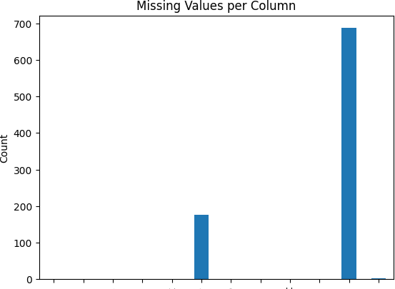

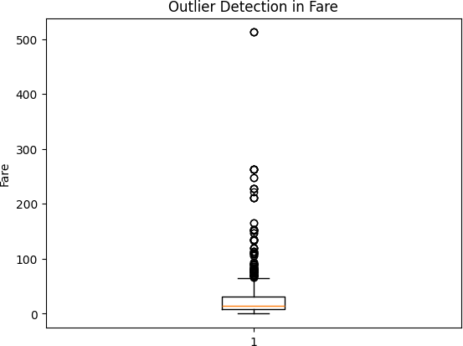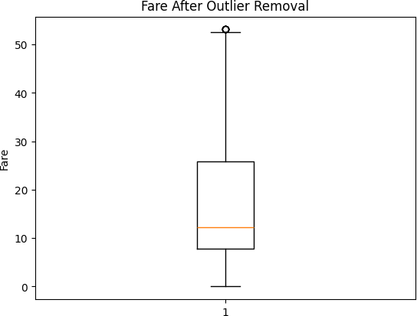

RESULT
Missing values in Age were imputed with mean, Embarked with mode, and Cabin was dropped due to high missingness. IQR-based outlier removal cleaned extreme Fare values, resulting in a well-distributed dataset ready for analysis.

